FORM 4: RESEARCH EVALUATION

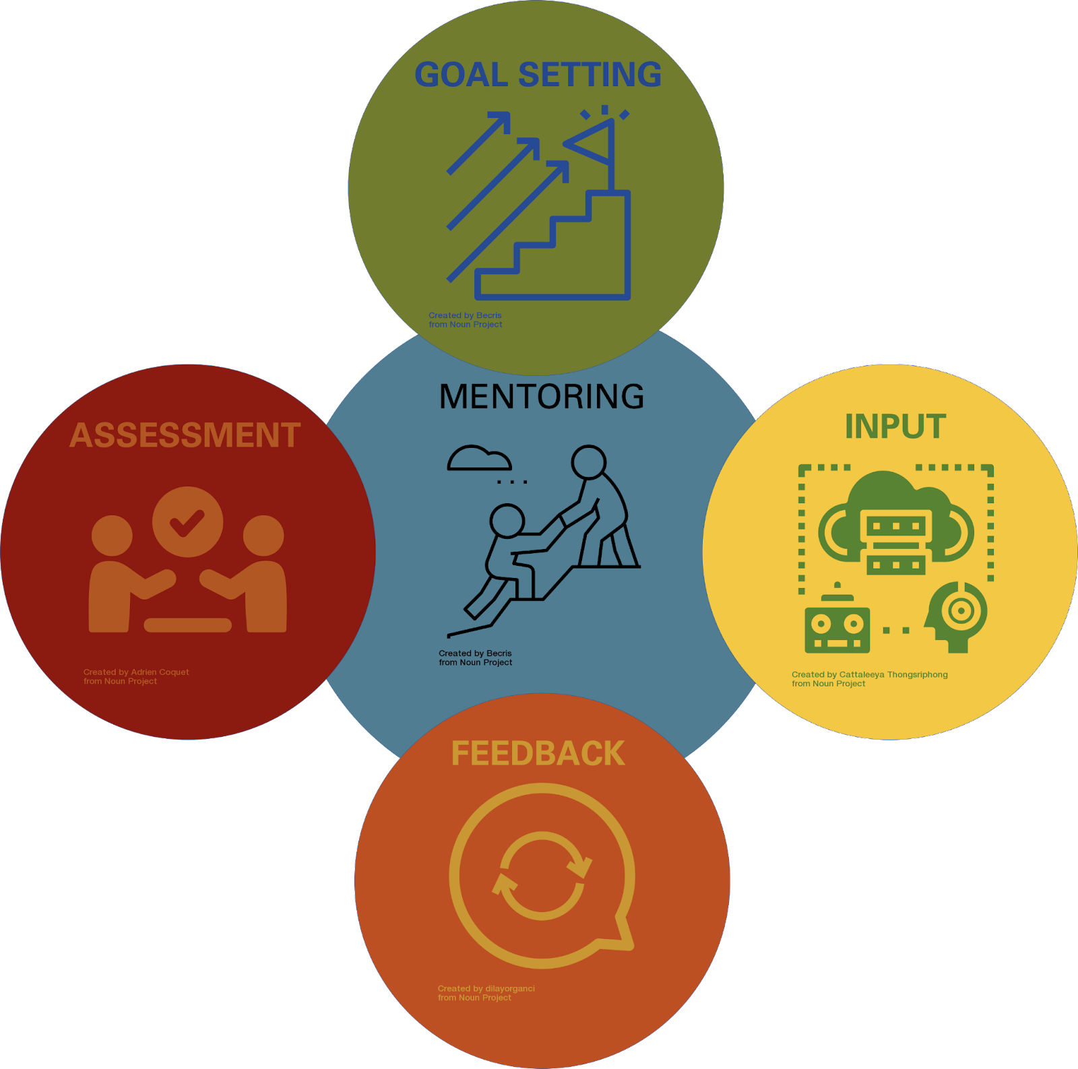

Evaluate the work, effort and accomplishments of our research together this semester! This should serve to celebrate the growth of a new researcher and to motivate their future STEM research goals!

UNDERGRADUATE RESEARCHER :___[NAME]_________________________________________

MENTOR / PI :___[NAME]________________________________________________________

MENTOR WILL COMPLETE FORM 4
What results has the undergraduate produced this semester?

Did these results meet goals of the previous set?

What are strengths that have been demonstrated?

What challenges have been overcome?

What are some areas that can be improved?

Future plans/goals?

UNDERGRADUATE SIGNATURE: ____________________________________________________
MENTOR SIGNATURE: ___________________________________________________________
DATE OF DISCUSSION: __________________________
Signatures designate these items were discussed by both mentor and undergraduate.

