FORM 2:
UNDERGRADUATE INPUT
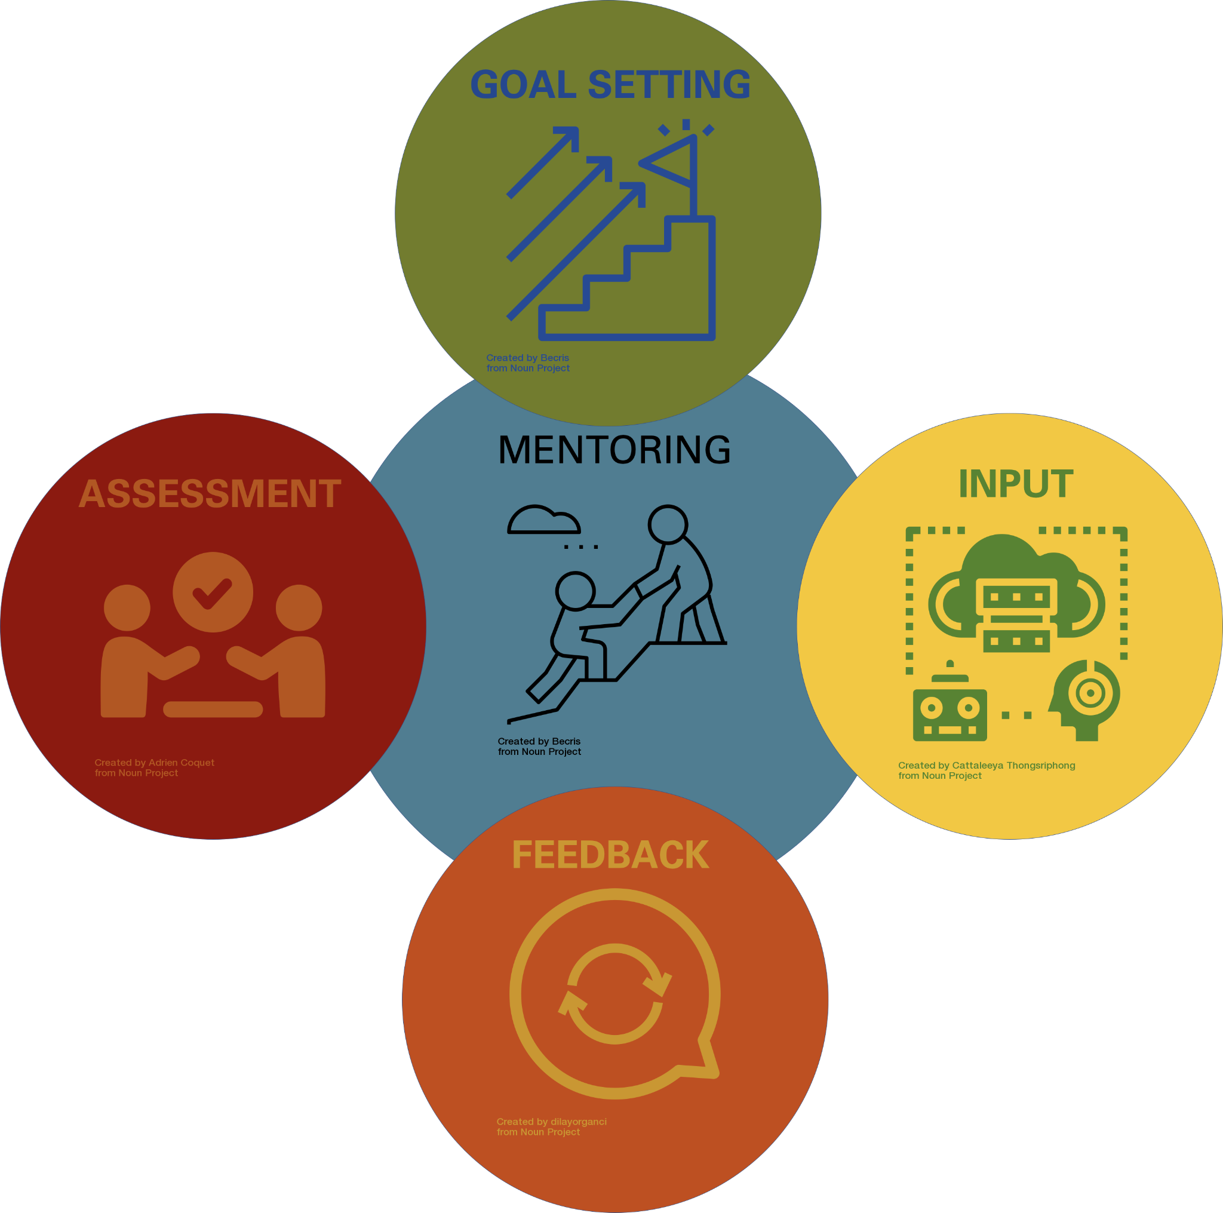

Reflect on the outline of our research goals for the semester. This should serve to help new researchers be successful and productive in the lab and to help you reach your ultimate career goals as well! The plans described here may change depending on the course of our project, and this should NOT be considered a contract of deliverables.

UNDERGRADUATE RESEARCHER :___[NAME]_________________________________________

MENTOR / PI :___[NAME]________________________________________________________

UNDERGRADUATE WILL COMPLETE FORM 2
Fill out the questions below to the best of your ability and as honestly as you can. Once completed, schedule a meeting with your mentor for you to discuss your reflection.

Current Research Progress:
- What have I completed for the project I am working on? (What results have I produced? What task am I most proud of accomplishing?)

- What have I gained from the work I have accomplished? (What new skills have I gained? New experiences I have gained? Relationships I have built that aid my productivity or potential?)

- What did I set out to do, that I have not yet attempted? Or has it not been completed?

Self-Reflection and Improvement
- What can I do to propel my project productivity?

- What assistance would I like to help me stay productive?

- What assistance would I like to help me overcome any setbacks?

Future Research Goals
- What research would I like to prioritize in the remainder of this semester?

- What research would I like to focus on in the next year?

Science Career Planning
- What larger problems would I enjoy using science to find creative solutions?

- What are my goals after college?

- How is my research this semester building knowledge, skills, and experience towards achieving my short term, long term and ultimate career goals?

- What important things would I like my mentor to know?
(Professional Questions | Scheduling Questions | Any concerns/questions/issues)

UNDERGRADUATE SIGNATURE: ____________________________________________________
MENTOR SIGNATURE: ___________________________________________________________
DATE OF DISCUSSION: __________________________
Signatures designate these items were discussed, as communicated by said undergraduate.

