FORM 1: GOAL SETTING
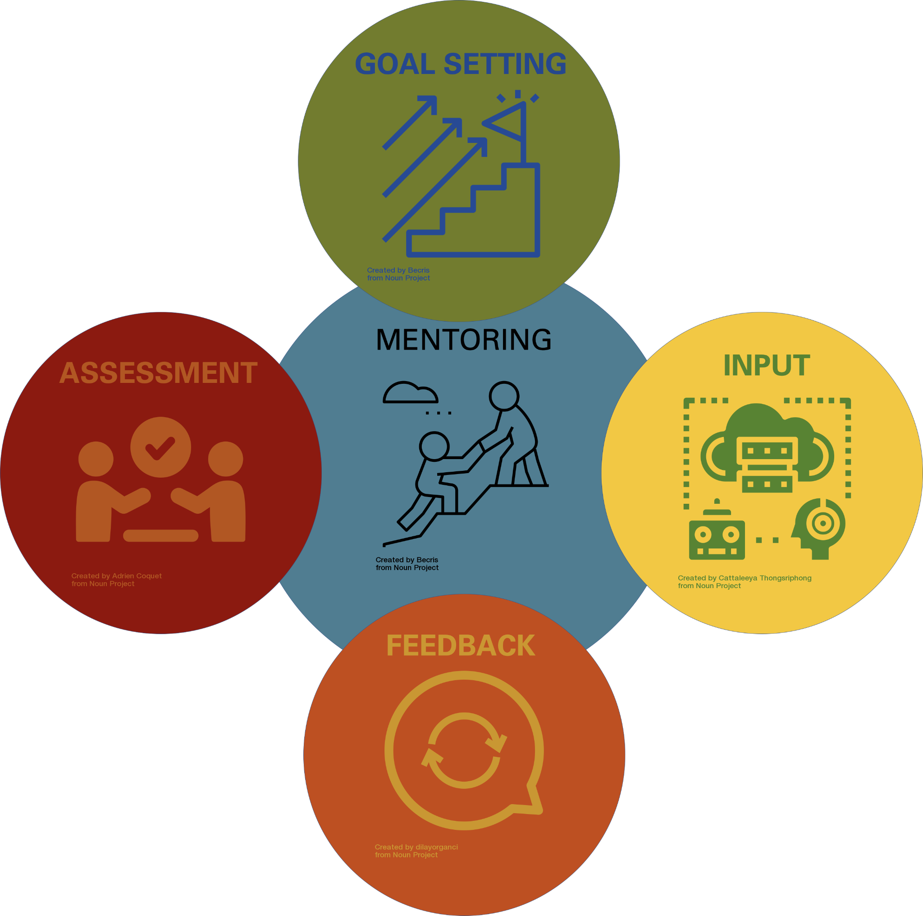

Together, let’s outline our research goals for the semester. This should serve to help you be successful and productive in the lab this semester (short-term goals), possibly in future semesters (intermediate-term goals), and to help you reach your ultimate career goals as well (long-term goals)! The plans described here may change depending on the course of our project, and this should NOT be considered a contract of deliverables.

UNDERGRADUATE RESEARCHER :___[NAME]_________________

MENTOR / PI :___[NAME]____________

PART1: MENTOR CAN COMPLETE
What project will the undergraduate researcher work on?

What will the undergraduate contribute to this project? What experiments will the undergraduate do?

How do these experiments fit into the project overall?

What skills are necessary to perform these experiments?

PART 2: UNDERGRADUATE WILL COMPLETE
What are your motivations for doing research?

What are your academic goals for this semester, and for your undergraduate tenure?

What do you see yourself doing 5 years from now?

What are your long-term career goals?

How does this research help you progress towards your goals?

UNDERGRADUATE SIGNATURE: ____________________________________________________
MENTOR SIGNATURE: ___________________________________________________________
DATE OF DISCUSSION: __________________________
Signatures designate these items were discussed by both mentor and undergraduate.

